NAME: EKENG, AKANINYENE IME
COURSE: SECURITY OPERATIONS CENTER (SOC) FUNDAMENTALS
COHORT: NOVARA 28 NOVERMBER 2025
DATE:18/02/2026

AIM: To understand the structure, purpose, processes, people, and technologies involved in a Security Operations Center (SOC), and to perform a practical simulation of SOC operations.

INTRODUCTION
A Security Operations Center (SOC) is a centralized unit responsible for continuously monitoring, detecting, analyzing, and responding to cybersecurity incidents within an organization.

MATERIALS
- TryHackMe platform access
- SOC Fundamentals lab environment
- Browser
- Basic knowledge of networking and cybersecurity

PROCEDURES
Step 1: Introduction to SOC
- I accessed the SOC Fundamentals room.
- I studied the role and objectives of a SOC.
- I understood the importance of 24/7 monitoring.
Step 2: Purpose and Components
  - I reviewed the core components: People, Process, and Technology.
  - I identified SOC roles and responsibilities.
Step 3: People in SOC
  - I learned about Tier 1, Tier 2, and Tier 3 analysts.
  - I understood escalation procedures.
Step 4: SOC Process
  - I studied the incident response lifecycle.
  - I learned how alerts are handled from detection to resolution.
Step 5: Technology
  - I explored SIEM systems and how logs are collected.
  - I understood the use of IDS/IPS and monitoring tools.
Step 6: Practical Exercise
- I participated in a simulated SOC scenario.
- I analyzed alerts generated in the system.
- I identified whether alerts were true positives or false positives.
- I practiced escalation and documentation.

OBSERVATION
- I observed that, not all alerts indicate real threats (false positives are common).
- I observed that, log analysis is critical for determining malicious activity.
- I observed that, clear documentation improves incident handling efficiency.
- I observed that, escalation procedures prevent delay in critical incidents.
- I observed that, continuous monitoring significantly reduces response time.

PRECAUTIONS
- I ensured proper log documentation during analysis.
- Avoid ignoring low severity alerts without verification.
- I followed escalation procedures strictly.
- I maintained confidentiality of sensitive data.
- I used secure systems when accessing lab environments.
- I ensured, i do not make assumptions without verifying evidence.

CONCLUSION
The SOC Fundamentals practical provided a comprehensive understanding of how a Security Operations Center functions. It demonstrated the importance of structured processes, skilled personnel, and advanced technologies in detecting and responding to cyber threats.
This practical exercise enhanced my knowledge on; Incident detection, Alert analysis, Escalation procedures, Documentation practices.
Overall, the SOC plays a critical role in protecting organizational assets from cyber threats by ensuring continuous monitoring, rapid detection, and effective incident response.

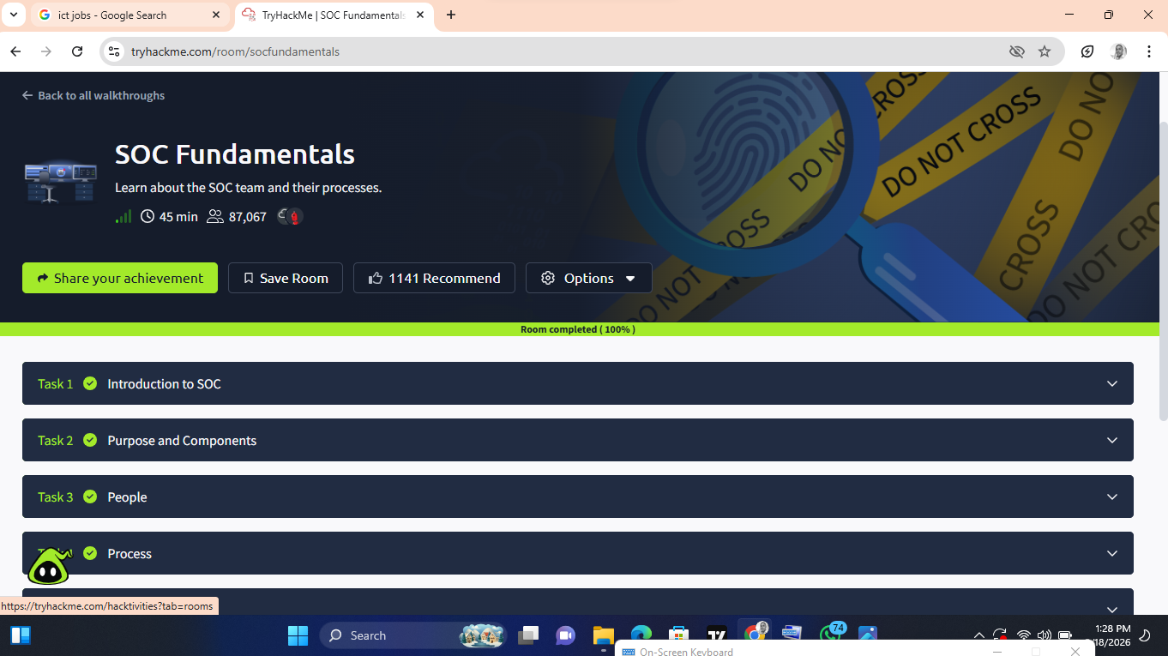
SCREENSHOT OF MY SUCCESSFUL COMPLETION.

